***REVOLUTIONIZING CUSTOMER SUPPORT WITH AN INTELLIGENT CHATBOT FOR AUTOMATED ASSISTANCE***

***STUDENT NAME****: IMAYA.V*

***REGISTER NUMBER****: 422623106031*

***INSTITUTION****: UNIVERSITY COLLEGE OF ENGINEERING PANRUTI*

***DEPARTMENT****: ELECTRONICS AND COMMUNICATION ENGINEERING*

***DATE OF SUBMISSION****:29/4/2025*

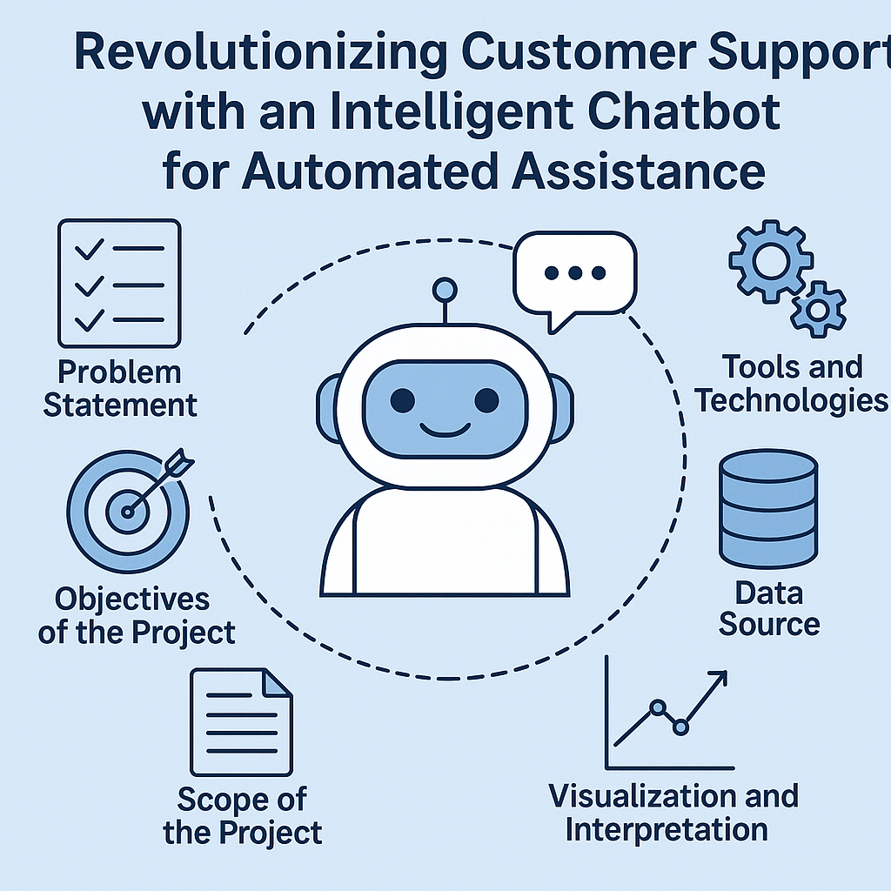

***Problem Statement***

***Introduction***

*Customer support plays a pivotal role in customer satisfaction and brand loyalty. Traditional customer support systems often face challenges like high response time, unavailability during off-hours, and inconsistent answers.*

***Problem Statement***

*Organizations struggle to meet increasing customer service demands due to:*

* *Long wait times and delayed resolutions.*
* *High operational costs for 24/7 support.*
* *Inconsistent support quality across channels.*
* *Difficulty in handling repetitive queries that consume agent time.*

***Hence, there is a critical need for an intelligent, automated solution that can handle customer queries efficiently and at scale.***

***Objectives of the Project***

***Main Objective***

*To design and develop an intelligent chatbot that automates customer support by providing instant, accurate, and consistent responses to customer queries.*

***Sub-objectives***

1. ***Query Classification:*** *Recognize and categorize customer queries effectively.*
2. ***Contextual Understanding:*** *Enable the chatbot to understand user intent using NLP.*
3. ***24/7 Availability:*** *Ensure the bot can operate continuously without human intervention.*
4. ***Live Agent Escalation:*** *Provide a smooth transition to a human agent when needed.*
5. ***Feedback Collection:*** *Gather customer feedback for continuous improvement.*

***Scope of the Project***

***In-Scope***

* *Development of a chatbot integrated with company FAQs and ticketing system.*
* *Use of NLP and machine learning for intent detection.*
* *Deployment on web platforms and optionally on mobile applications.*
* *Basic analytics and reporting dashboard for support activity.*

***Out-of-Scope***

* *Voice-based customer support (focus is on text/chat only).*
* *Development of backend CRM systems (assumes integration with existing systems).*
* *Multilingual support (initially restricted to English).*

***Data Source and High-Level Methodology***

***Data Sources***

1. ***Company FAQs:*** *Frequently asked questions from the business's existing support database.*
2. ***Customer Support Tickets:*** *Historical tickets categorized by issues and resolution.*
3. ***Chat Logs:*** *Past interactions from live chat platforms.*
4. ***Feedback Forms:*** *Data from customer feedback surveys.*

***High-Level Methodology***

1. ***Data Collection & Cleaning:*** *Extract and preprocess chat logs, FAQs, and support tickets.*
2. ***Intent Recognition:*** *Train NLP models (e.g., using BERT, spaCy) for intent classification.*
3. ***Response Generation:*** *Use rule-based and generative models for formulating answers.*
4. ***Chatbot Development:*** *Integrate trained models into a conversational framework (e.g., Rasa or Dialogflow).*
5. ***Evaluation & Tuning:*** *Monitor performance via metrics like precision, recall, and customer satisfaction.*

***Visualization and Interpretation***

***Chatbot Performance Metrics***

* ***Confusion Matrix:*** *To assess classification accuracy of intents.*
* ***Precision & Recall:*** *For evaluating correct query understanding.*
* ***Customer Satisfaction (CSAT):*** *Visualization of average feedback score over time.*

***Sample Visualizations***

1. ***Intent Detection Accuracy by Category:*** *Bar chart comparing accuracies.*
2. ***Query Volume Over Time:*** *Line chart showing volume before and after chatbot deployment.*
3. ***Resolution Time Comparison:*** *Pie charts comparing average resolution times with and without chatbot.*

***Interpretation***

*The chatbot should show:*

* *A reduction in average response and resolution times.*
* *Increase in number of queries handled automatically.*
* *Higher customer satisfaction from quick and accurate responses.*

***Tools and Technologies***

***Tools***

* ***Rasa / Dialogflow / Microsoft Bot Framework:*** *For building and deploying the chatbot.*
* ***Python / TensorFlow / PyTorch:*** *For model training and backend processing.*
* ***NLTK / spaCy / BERT:*** *For natural language processing tasks.*
* ***PostgreSQL / MongoDB:*** *For storing chat logs and training data.*
* ***Tableau / Power BI / Matplotlib / Seaborn:*** *For visualization and reporting.*
* ***Slack / WhatsApp / Web Chat Plugin:*** *For deployment and customer interaction channels.*

***Technology Stack***

| ***Layer*** | ***Technology Used*** |
| --- | --- |
| *Frontend* | *ReactJS, Web Chat Plugin* |
| *Backend* | *Python, Flask, FastAPI* |
| *NLP Models* | *BERT, spaCy* |
| *Data Storage* | *PostgreSQL, MongoDB* |
| *Deployment* | *Docker, Kubernetes, AWS* |

***Team Members And Roles***

|  |  |  |
| --- | --- | --- |
| *Name* | *Role* | *Responsibilities* |
| *Imaya.V* | *Project leader* | *Oversee project development, coordinate team activities, ensure timely delivery of milestone, and contribute to documentation and final presentation* |
| *Srividhya.S* | *Datamanager* | *Collect data from APIs(eg:twitter), manage dataset storage, clean and preprocess text data, and sensure quality of input data* |
| *Sumithra.E* | *EDA and visualization specialist* | *Performing exploratory data analysis(EDA)-creating detailed graphs(bar plot, pie chart, heatmap, scatter plot)-interpreting trend sand relationships in data* |
| *Lingeshwari.S* | *Research And Documentation manager* | *Writing the problem statement, objective, and organizing the final report-researching best practices and algorithms* |